Staggered Peer-Assisted Learning (SPAL): A Tiered Reciprocal Support Protocol in Pre-University Physics

By Shafiq Rasulan

# 1.0 Abstract

This report introduces the **Staggered Peer-Assisted Learning (SPAL)** protocol, a tiered peer collaboration strategy designed to address performance disparities in pre-university physics classrooms. Grounded in Vygotsky’s Zone of Proximal Development, Social Interdependence Theory, and principles of peer-assisted learning, SPAL organizes students into performance-based groups and enables reciprocal support through a cascading model of peer assistance. Higher-performing groups assist adjacent lower groups upon task completion, while lower-performing groups simultaneously support those directly above them. This structure promotes equitable participation, metacognitive development, and reduced dependence on teacher mediation. Although empirical data are not yet available, theoretical analysis suggests that SPAL holds promise as a minimalist, scalable approach to fostering collaborative learning, academic engagement, and conceptual understanding in diverse learning environments.

# 2.0 Background & Rationale

In classrooms with wide academic ability ranges, particularly in pre-university settings like the Malaysian matriculation system, managing differentiated learning effectively presents a recurring challenge. While some students excel quickly in mastering physics concepts, others require sustained support and repeated exposure to consolidate their understanding. Traditional teacher-centered approaches often fail to address this gap in real-time, risking disengagement among both high-performing and struggling learners.

To respond to this challenge, the **Staggered Peer-Assisted Learning (SPAL)** protocol was developed. SPAL is a structured, tiered form of collaborative learning designed to harness **peer-to-peer support** in a dynamic, cascading manner. Students are first grouped in performance-based dyads and ranked from strongest (Group 1) to weakest (Group 10). After each group completes a given task, they are instructed to assist the next adjacent group—Group 1 helps Group 2, Group 10 helps Group 9, and so on—until the entire class completes the task. This design fosters **horizontal peer collaboration within ability tiers** and **vertical instructional flow across performance levels**.

## Grounding in Pedagogical Theory

The SPAL protocol is anchored in several key educational theories and models that support cooperative, differentiated, and student-centered learning:

### Vygotsky’s Zone of Proximal Development (ZPD)

Lev Vygotsky’s theory of the **Zone of Proximal Development** posits that learners can perform more complex tasks with the guidance of a more knowledgeable peer than they could alone.

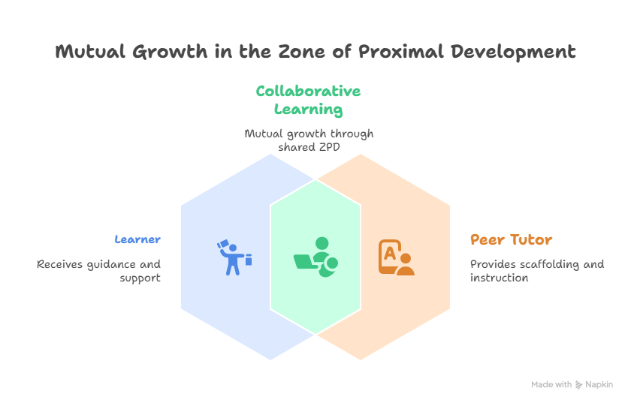

SPAL is explicitly designed to exploit this principle by facilitating interactions between students of adjacent performance levels. By staggering assistance rather than assigning fixed tutor-tutee pairs, SPAL enables each student to function both as a learner and a teacher within their own ZPD—enhancing engagement and deepening conceptual understanding on both ends.

### Social Interdependence Theory

Proposed by Deutsch and further developed by Johnson & Johnson (2009), **Social Interdependence Theory** emphasizes that learning outcomes improve when students perceive their success as linked to the efforts of their peers. SPAL operationalizes this through **positive interdependence**: students know that their completion not only marks personal progress but also serves as the basis for helping others. This fosters a prosocial learning environment where helping behavior, collective responsibility, and mutual respect are reinforced.

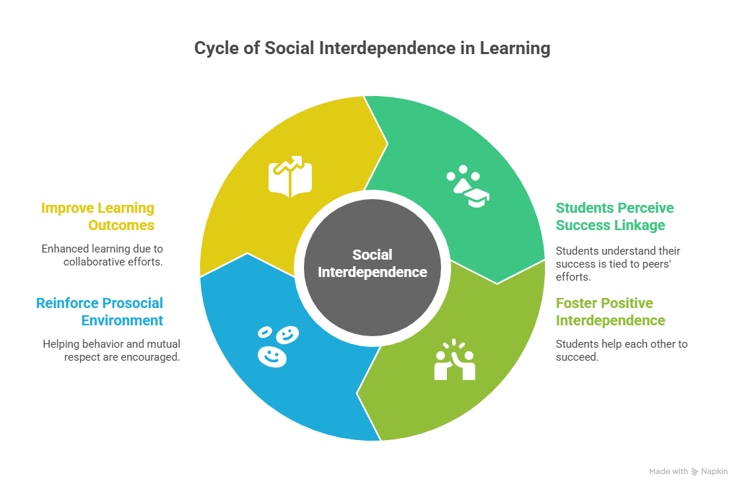

### Peer-Assisted Learning Strategies (PALS)

SPAL builds on the core principles of **Peer-Assisted Learning Strategies (PALS)**, which have demonstrated effectiveness in various subjects including mathematics, reading, and science. Like PALS, SPAL involves reciprocal interactions and requires students to verbalize their thinking. However, SPAL introduces a **staggered, tiered design** rather than static pairs or small groups. This addresses one common limitation of peer tutoring models—overreliance on fixed strong-weak dyads—by introducing fluid, adjacent support dynamics that maintain dignity and relevance for all students.

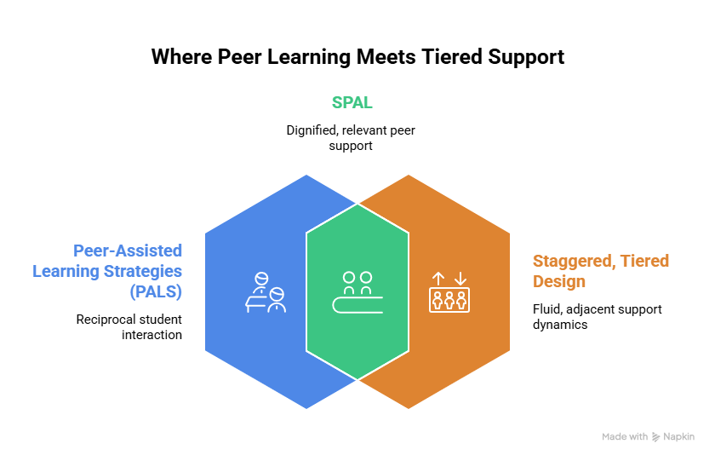

### Constructivist Learning Theory

From a constructivist perspective, learning occurs through active engagement and social negotiation of meaning. SPAL structures learning interactions to encourage students to articulate reasoning, pose questions, and explain solutions to one another. This peer dialogue stimulates **cognitive conflict** and promotes the construction of deeper understanding, particularly when students must simplify complex ideas for others—a process known to benefit both the explainer and the recipient.

### Minimal Guidance and Scaffolding

SPAL aligns with the principle of **minimal but strategic teacher intervention**. Rather than directly instructing each group, the teacher facilitates the protocol structure and monitors its flow. This provides opportunities for **student autonomy**, peer-led scaffolding, and **self-regulated learning**, while allowing the teacher to focus attention on groups needing targeted support.

### Conclusion

In sum, the Staggered Peer-Assisted Learning protocol is not only a practical classroom strategy for addressing performance disparity but also a theoretically grounded model that integrates Vygotskian social constructivism, peer-assisted learning theory, and principles of cooperative learning. By leveraging adjacent-peer dynamics and staged collaboration, SPAL promotes deeper understanding, social accountability, and equitable participation—factors critical to inclusive and effective physics instruction at the pre-university level.

# 3.0 Protocol Description

The **Staggered Peer-Assisted Learning (SPAL)** protocol is a structured classroom strategy designed to facilitate reciprocal peer support across student ability levels in a manageable and scalable way. The core mechanics rely on organizing students into ranked performance-based groups, assigning collaborative tasks, and enabling assistance to flow *both downward and upward* through staggered peer interaction.

## Student Grouping Strategy

At the start of the session or instructional unit, students are ranked based on their most recent assessment results or diagnostic performance. They are then paired into dyads or small groups (e.g., 2–3 students per group), sorted from highest to lowest in terms of performance. These are labeled as **Group 1 (strongest)** through **Group 10 (weakest)**. The pairing is intended to reflect relatively similar ability within each group to support initial collaboration and reduce cognitive mismatch.

|  |
| --- |
| *Example*: Group 1 consists of the top two students, Group 2 the next two highest, and so forth down to Group 10. |

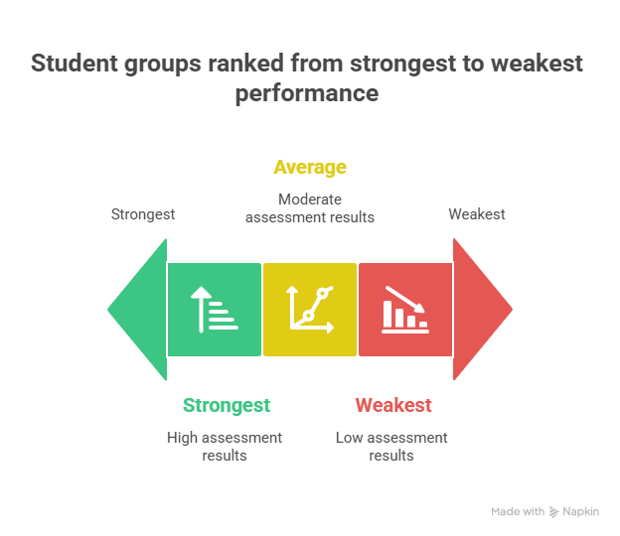

## Task Assignment

All groups are given a common task or parallel versions of a task—such as a conceptual physics question, a multi-step problem, or a short worksheet. The task should:

* Be sufficiently challenging to require discussion
* Involve reasoning or explanation (not just computation)
* Be completable within a fixed time frame (e.g., 15–20 minutes)

The teacher provides minimal instruction, allowing students to engage with the content through peer negotiation and collaborative reasoning.

## Staggered Peer Collaboration Flow

Once tasks are underway, the SPAL protocol governs how peer support proceeds:

1. **High-to-Low Cascade:**

When **Group 1** finishes the task and checks their solution (independently or with teacher verification), they are instructed to assist **Group 2**. If Group 2 is still working, they receive guidance; if finished, Group 1 moves to **Group 3**, and so on.

1. **Low-to-High Cascade:**

Simultaneously, when **Group 10** finishes, they initiate collaboration with **Group 9** (if unfinished). This upward assistance ensures lower-performing groups are not left idle and still have meaningful roles as peer supporters.

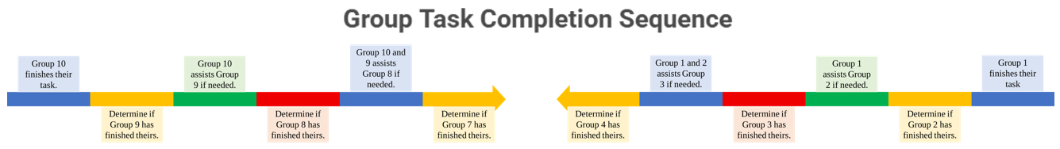

This two-directional flow allows:

* High-performing students to practice **teaching and articulation**
* Mid-performing students to receive **tiered support**
* Lower-performing students to **both give and receive assistance**, promoting dignity and inclusion

## Teacher’s Role

The teacher functions as a **monitor and facilitator**, not a direct instructor during the activity. Responsibilities include:

* Observing group dynamics
* Clarifying misconceptions when peer explanations break down
* Ensuring groups follow the staggered protocol
* Debriefing and summarizing key concepts post-activity

The teacher may also strategically intervene by directing peer interactions, e.g., “Group 4, please check in with Group 5—they might benefit from your approach.”

## Optional Enhancements

To increase engagement or accountability, the protocol may be enhanced by:

* **Structured reflection**: Groups explain their final answers on a board or document
* **Role assignments**: Within groups (e.g., explainer, checker, questioner)
* **Timed phases**: E.g., 10 min solo group work + 10 min peer support phase
* **Formative feedback**: Quick quizzes or exit tickets post-activity

# 4.0 Possible Strengths and Limitations

Although the Staggered Peer-Assisted Learning (SPAL) protocol has not yet been formally evaluated in the current instructional context, its design is grounded in well-established pedagogical principles. Drawing from relevant literature on cooperative learning, peer-assisted strategies, and social constructivism, the following section outlines the hypothesised strengths and limitations of SPAL, as inferred from theoretical alignment and prior empirical findings.

## Hypothesised Strengths

One of the central strengths of the SPAL protocol lies in its capacity to facilitate **bidirectional peer learning**. By allowing assistance to flow both downward (from higher-performing groups to lower ones) and upward (from lower-performing groups to those immediately above), SPAL extends the conventional peer tutoring framework into a more **reciprocal and dynamic model**. This structure resonates with Vygotsky’s (1978) concept of the *Zone of Proximal Development* (ZPD), in which learners benefit most from interactions with peers slightly more capable than themselves. The proximity in ability between supporting and receiving groups is intentionally narrow, preserving cognitive accessibility while promoting meaningful scaffolded dialogue.

Moreover, SPAL promotes **positive interdependence** among learners, a core construct in **Social Interdependence Theory** (Johnson & Johnson, 2009). As students recognise that their task completion enables them to assist others, their sense of social responsibility and intrinsic motivation may increase. This type of interdependence has been associated with enhanced academic achievement, greater persistence, and improved group cohesion (Gillies, 2003).

In addition, the protocol is expected to foster the development of **metacognitive and communication skills**, particularly among higher-performing students who take on instructional roles. The act of explaining problem-solving strategies to peers requires not only conceptual clarity but also metacognitive monitoring and audience awareness. Previous research on reciprocal teaching and peer-assisted learning strategies (Fuchs et al., 1997; Topping, 2005) suggests that such experiences can deepen understanding for both the explainer and the recipient.

SPAL may also contribute to **reduced dependence on teacher mediation**, especially during problem-solving sessions. By embedding the instructional support within the peer group structure, the protocol aligns with principles of **self-regulated learning** and **minimal guidance instruction** (Kirschner, Sweller & Clark, 2006). Students are encouraged to take ownership of their learning process while still receiving timely peer feedback when needed.

Importantly, SPAL is designed to uphold **student dignity and inclusiveness**, particularly for lower-performing groups. Unlike fixed-role peer tutoring models that often label students as “helpers” and “helpees,” SPAL’s staggered, adjacent-tier collaboration avoids stigmatization. All students participate as both contributors and learners, which may support the development of a **growth mindset** and reduce anxiety commonly associated with open comparison of ability levels.

## Anticipated Limitations

Despite its potential benefits, SPAL is not without anticipated challenges. One concern involves the **uneven quality of peer explanation**. Not all students possess the pedagogical skill to guide their peers effectively, and in some cases, inaccurate explanations may reinforce misconceptions rather than correct them. As Topping (2005) cautions, peer learning models are most successful when students receive explicit training in providing feedback, prompting reasoning, and verifying correctness.

The protocol’s success is also contingent upon the **quality of group dynamics**. Effective peer collaboration requires mutual respect, active participation, and willingness to engage in constructive dialogue—factors which may vary significantly across groups. In cases of interpersonal conflict, disengagement, or social loafing, the intended benefits of reciprocal support may be diminished (Slavin, 1996).

Furthermore, **time management** may pose practical difficulties. Depending on the complexity of the task, the rate at which different groups complete their work may vary considerably, potentially disrupting the staggered flow of support. Without clear time structures or facilitative teacher intervention, early-finishing groups may become idle or dominate the explanation process, while slower groups may be left unsupported.

Lastly, SPAL assumes a relatively narrow performance gap between groups, which may not always be present in heterogeneous classrooms. If the cognitive distance between adjacent groups is too great, peer explanations may become either overly simplified or cognitively inaccessible. This limitation underscores the importance of **careful group formation** and **ongoing formative assessment** to ensure alignment between learners' zones of proximal development.

# Conclusion

The **Staggered Peer-Assisted Learning (SPAL)** protocol represents a structured yet flexible approach to facilitating peer collaboration in mixed-ability classrooms. By pairing students within performance tiers and allowing peer support to flow both downward and upward through adjacent groups, SPAL is designed to promote reciprocal learning, metacognitive development, and inclusive participation. Unlike static peer tutoring arrangements, SPAL incorporates a dynamic interaction model in which all students have the opportunity to serve as both learners and facilitators of learning.

The protocol is theoretically grounded in several robust pedagogical frameworks, including **Vygotsky’s Zone of Proximal Development**, **Social Interdependence Theory**, and **constructivist learning models**. These foundations suggest that learning is optimized through peer dialogue, social accountability, and scaffolded explanation—all of which are embedded in the SPAL structure.

While formal data on its impact has yet to be collected, the hypothesised strengths of SPAL include improved engagement, deeper conceptual understanding, and reduced dependence on teacher-led instruction. At the same time, the protocol acknowledges limitations related to the quality of peer interaction, task pacing, and group dynamics. Future iterations may benefit from explicit peer training, clearer timing structures, and formative assessment integration.

Overall, SPAL offers a minimalist but pedagogically sound strategy for supporting academic collaboration in physics and other cognitively demanding subjects. It provides a practical means of leveraging the diversity of student abilities in service of collective progress—aligning classroom practice with the broader goals of equity, autonomy, and deeper learning.

Attachment: Teacher-facing summary

**Teacher-Facing Summary: Staggered Peer-Assisted Learning (SPAL)**

**What is SPAL?**

**Staggered Peer-Assisted Learning (SPAL)** is a structured collaborative learning protocol where students are grouped based on performance and engage in tiered peer support. It is designed to maximize engagement, deepen understanding, and promote inclusive peer learning.

**Key Objectives**

* Provide structured peer support without over-reliance on the teacher
* Encourage both strong and weak students to participate meaningfully
* Promote active learning, peer explanation, and metacognitive growth

**How to Implement SPAL**

|  |  |  |
| --- | --- | --- |
| **Step** | **Action** | **Purpose** |
| **1. Group Formation** | Rank students by recent test/quiz scores. Pair them into 10 groups: Group 1 = strongest, Group 10 = weakest. | Ensures ability proximity for effective peer support |
| **2. Task Distribution** | Provide a common or tiered problem-solving task to all groups. Avoid tasks that are too simple or purely procedural. | Encourages reasoning, discussion, and explanation |
| **3. Independent Group Work** | Each group works independently to complete the task. Set a target time (e.g., 10–15 minutes). | Promotes group accountability and initial problem engagement |
| **4. Staggered Support Flow** | When Group 1 finishes, they assist Group 2 (if not done), then Group 3, and so on. Meanwhile, Group 10 assists Group 9, then Group 8, etc. | Enables reciprocal support without labeling or dependency |
| **5. Debrief** | Select key ideas from the task and lead a short class discussion or reflection. Optionally ask groups to share solution strategies. | Consolidates learning and addresses misconceptions |

**Teacher’s Role**

* Observe quietly during group work
* Only intervene if groups stall or propagate misconceptions
* Prompt metacognitive questioning (e.g., “How do you know that?”)
* Monitor fairness in participation within and across groups

**What Works Best**

* Tasks with multiple solution steps or common misconceptions
* Grouping based on **adjacent performance levels**
* Time limits or check-in milestones
* Classroom culture that rewards effort and collaboration

**Watch Out For**

* Dominance by stronger groups or students
* Inaccurate peer explanations (correct only when needed)
* Off-task behavior during wait times (have a backup extension activity)
* Too large a performance gap between adjacent groups (reassign if needed)

**Based On These Theories**

* **Vygotsky’s Zone of Proximal Development** (learning via slightly more capable peers)
* **Social Interdependence Theory** (mutual success drives motivation)
* **Peer-Assisted Learning Strategies (PALS)** (learning through explaining)
* **Constructivist Theory** (knowledge built through social interaction)